**DYNAMIC CONCEALMENT IN RECITAL VISUAL BLOCKCHAIN**

**Preface**

**TABLE OF CONTENTS**

**1. SOFTWARE DEVELOPMENT LIFE CYCLE**

**2. PLATFORM KNOWLEDGE**

**3. ABOUT PROJECT**

3.1 ABSTRACT

3.2 SCOPE OF THE PROJECT

3.3 EXISTING SYSTEM

3.3.1 DISADVANTAGES

3.4 PROPOSED SYSTEM

3.4.1 ADVANTAGES

**4. BOTTOM LINE AND FUTURE ENHANCEMENT**

**5. HARDWARE AND SOFTWARE REQUIREMENTS**

**1. SDLC (Software Development Life Cycle)**

The Software Development Life Cycle is a systematic process for building software that ensures the quality and correctness of the software built. SDLC process aims to produce high-quality software which meets customer expectations. The software development should be completed within the pre-defined time frame and cost.

**SDLC Phases**

The entire SDLC process is divided into the following stages:

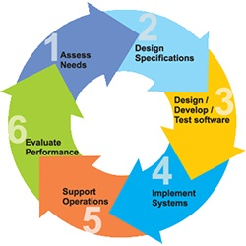

* Phase 1: Requirement collection and analysis
* Phase 2: Feasibility study
* Phase 3: Design
* Phase 4: Coding
* Phase 5: Testing
* Phase 6: Installation/Deployment
* Phase 7: Maintenance

**2. Platform Knowledge**

**Introduction to Python:**

Python is developed by Guido van Rossum. Guido van Rossum started implementing Python in 1989. Python is a facile programming language so even if you are new to programming, you can learn python without facing any issues. Python is a general-purpose programming language that is becoming ever more popular for data science. Companies worldwide are using Python to harvest insights from their data and gain a competitive edge. Python specifically for data science. To store and manipulate data, and helpful data science tools to begin conducting your own analyses.

**What is Python?**

Python is an [interpreted](https://en.wikipedia.org/wiki/Interpreted_language), high-level, general purpose [programming language](https://en.wikipedia.org/wiki/Programming_language). It is [dynamically typed](https://en.wikipedia.org/wiki/Dynamic_programming_language) and collected. Python is an interpreted language and not a compiled one, although compilation is a step. Python code, written in **.py** file is first compiled to what is called byte code which is stored with a **.**pyc or **.**pyo format. Instead of translating source code to machine code like C++, Python code it translated to byte code. This byte code is a low-level set of instructions that can be executed by an interpreter. One popular advantage of interpreted languages is that they are platform-independent. As long as the Python byte code and the Virtual Machine have the same version, Python byte code can be executed on any platform (Windows, MacOS, etc).Dynamic typing is another advantage. In static-typed languages like C++, you have to declare the variable type and any discrepancy like adding a string and an integer is checked during compile time*.* In older programming languages, memory allocation was quite manual. Many times when you use variables that are no longer in use or referenced anywhere else in the program, they need to be cleaned from the memory. Garbage Collector does that for you.

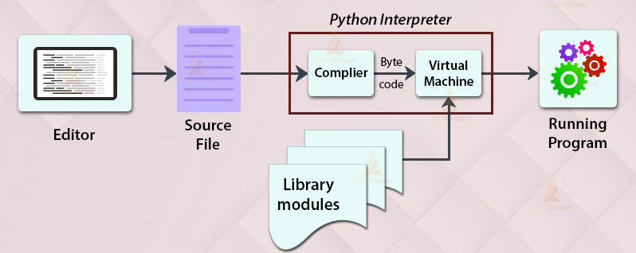

**DYNAMIC CONCEALMENT IN RECITAL VISUAL BLOCKCHAIN**

**3. About the project:**

**3.1 Abstract:**

Banking and technology are very closely associated and innovations have changed banking drastically over the period of time. The digital innovations in the banking sector started with the introduction of money that replaced the barter system and then the gradual replacement of wax seal with digital signatures. One such disruptive innovation which is changing the banking sector globally is Blockchain Technology (BCT). Blockchain is shared distributed ledger which stores business transaction to a permanent unbreakable chain which can be viewed by the parties in a transaction. Blockchain technology has the potential to disrupt the ﬁnancial business applications as it provides permanent and tamper proof recording of transactions in a distributed network. It can be widely applied in digital currency, trade finance, KYC and cross border remittances, etc. Although the potential of blockchain is enormous, it has various limitations of security, privacy and scalability which need to be addressed. The aim of this paper is to provide the overview of blockchain technology with its benefits and emphasizing on the applications of the technology in the Indian Banking Sector. The paper gives the insight of various challenges and global perspective of blockchain technology in Banking Industry. The utility of Blockchain is that financial transactions no longer require any central authority and are immediately validated, cleared and settled. Blockchain technology appears to be an innovation which promises a major change for capital markets and other financial services.

**3.2 Scope of the project:**

The banking sector stands to gain a lot by replacing their outdated systems for settling transactions with the newest offerings from the likes of Ripple and its competitors. Ripple is designed to be a high throughput blockchain which could handle upwards of 1500 transactions per second. Ripple achieves this by sharing the authentication privileges with a limited number of trusted nodes that can be run by banks themselves or public institutions such as universities. This gives banks with official records of asset ownership as the authenticators are legally responsible for processing transactions honestly. Switching over to Ripple’s xRapid service could help expedite their transaction settlements many times over while at the same time reducing their costs by over 40%. Ripple’s two main offering for bank-to-bank transfers are xCurrent and xRapid. xCurrent similar to the SWIFT messaging system and allows for settlement in cross-border payments but still requires traditional banking accounts to be held by participating banks. The real benefits of blockchains can, however, be seen in the xRapid system which utilizes Ripple’s native XRP token. xRapid significantly improves speed and reduces costs for cross-border payments by using XRP as a bridge asset between currencies thus eliminating the need for traditional banking accounts..

**3.3 Existing system:**

In a previous system, Blockchain offers an innovative approach to storing information, executing transactions, performing functions, and establishing trust in an open environment. Many consider blockchain as a technology breakthrough for cryptography and cyber security, with use cases ranging from globally deployed crypto currency systems like This paper presents a comprehensive overview of the security and privacy of blockchain. To facilitate the discussion, we first introduce the notion of blockchains and its utility in the context of Bitcoin like online transactions. Then we describe the basic security properties that are supported as the essential requirements and building blocks for Bitcoin like crypto currency systems, followed by presenting the additional security and privacy properties that are desired in many blockchain applications. Finally, we review the security and privacy techniques for achieving these security properties in blockchain-based systems, including representative consensus algorithms, hash chained storage, mixing protocols, anonymous signatures, non-interactive zero-knowledge proof, and so forth. We conjecture that this survey can help readers to gain an in-depth understanding of the security and privacy of blockchain with respect to concept, attributes, techniques and systems

**3.3.1 Disadvantages:**

* Use excessive energy
* Implementation of cyber security is difficult
* Huge distributed computing system
* Mining does not provide network security
* Entries do not last forever or are not immutable

**3.4 Proposed system:**

In my project, Blockchain technology is a new technology which is based on mathematical, cryptographic and economic principles for maintaining a database between various participants without the requirement of any third party or central authority. It is a secured distributed database, tamper evident, wherein the validity of a transaction can be verified by parties in the transaction. Each group of these transactions is referred to as a “block”. A Block records some or all of the recent transactions and goes into a blockchain as a permanent record once completed. Provide the overview of blockchain technology with its benefits emphasizing on the applications of the technology in the Indian Banking Sector. The paper gives the insight of various challenges and global perspective of blockchain technology in Banking Industry.

**Advantages:**

* **Reduced Transaction Costs**
* **Trustworthy Distributed Systems**
* **Increased Stability**
* **Improved Security & Financial Efficiency**
* **Instant Payments at Reduced Costs**

**4. BOTTOM LINE ND FUTURE ENHANCEMENT:**

In my project, Blockchain technology is the growing invention which includes a chain of blocks. A Blockchain is a distributed or a digital ledger, which is primarily created to record the details of each financial and non-financial transaction. The absolute and permanent data is stored in a distributed database. The entire record is completely transparent which means that anyone who is linking to the network is able to view the transactions. Fundamentally, the Blockchain technology is the combination of three technologies, i.e. private key cryptography, P2P network, and the program. The Blockchain technology has shown its revolution in the field of information registration and distribution which removes the requirement for an intermediary expert to enable the digital relationships. Blockchain technology has provided the most popular product, i.e. Bitcoin which is a type of crypto currency and functions as a public ledger for all transactions happening on the network. It has resolved the problem of double spending, unauthorized spending, and thus increasing security. It also helps to remove the need for an intermediary expert. Since there has been a substantial increase in the number of cyber-attacks recently, the Blockchain technology helps to attract the varied audience.

**5. System Requirement:**

**Software Requirements:**

Operating system: Windows 7, 8 and new versions

Coding Language: PYTHON

Tool: Pycharm

Database: MYSQL

**Hardware Requirements:**

System: Pentium Dual Core

Hard Disk: 120 GB and above

Monitor: 15’’ LED

Input Devices: Keyboard, Mouse

Ram: 4 GB